**Computer Science 204: Database Programming**

*Assignement 1*

Name: Myranda Brandt

**Index**

Part A ………………………………………………………………………………………………………………. 2

Part B ………………………………………………………………………………………………………………. 6

Part C ………………………………………………………………………………………………………………. 26

Question 1 ………………………………………………………………………………………………. 26

Question 2 ………………………………………………………………………………………………. 27

Question 3 ………………………………………………………………………………………………. 29

Question 4 ………………………………………………………………………………………………. 30

Question 5 ………………………………………………………………………………………………. 31

Question 6 ………………………………………………………………………………………………. 32

Question 7 ………………………………………………………………………………………………. 33

Question 8 ………………………………………………………………………………………………. 34

Question 9 ………………………………………………………………………………………………. 35

Question 10 …………………………………………………………………………………………….. 38

Question 11 …………………………………………………………………………………………….. 39

Question 12 …………………………………………………………………………………………….. 40

Question 13 …………………………………………………………………………………………….. 41

Question 14 …………………………………………………………………………………………….. 42

INDEX ………………………………………………………………………………………………………………. 43

**Part A. Create the database, tables, and relationships needed for the foundation of the public library database, pictured in Figure 1.**

/*First, I need to create the actual database the tables are going to go in. I'll name the library Baldwin Library*/

CREATE DATABASE BaldwinLibrary;

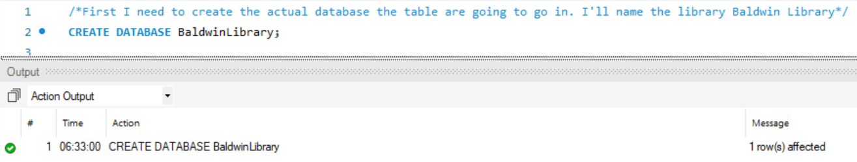

/*Next I need to make sure I am using the new database I created, I'll switch over to it*/

USE BaldwinLibrary;

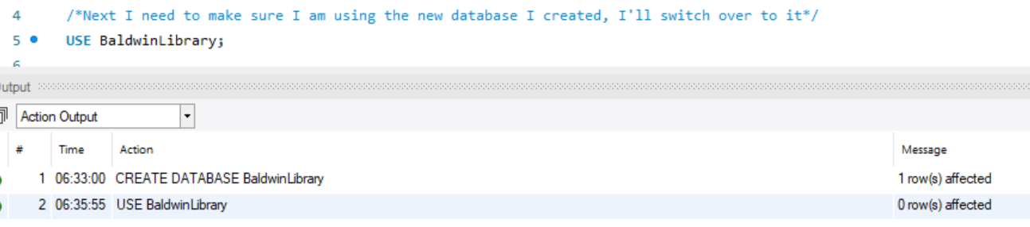

/*Now I will create the tables. I'll start with the Author table. The AuthorID will be the Primary Key and using that constraint will take care of requiring it to be unique and not null. All authors should have a first and last name, so I will make those not null. A authors nationally could be unknown at the time of entry, so I will default that to unknown if it's not entered.*/

CREATE TABLE Author

(AuthorID INT PRIMARY KEY,

AuthorFirstName VARCHAR(100) NOT NULL,

AuthorLastNAme VARCHAR(100) NOT NULL,

AuthorNationality VARCHAR(200))

;

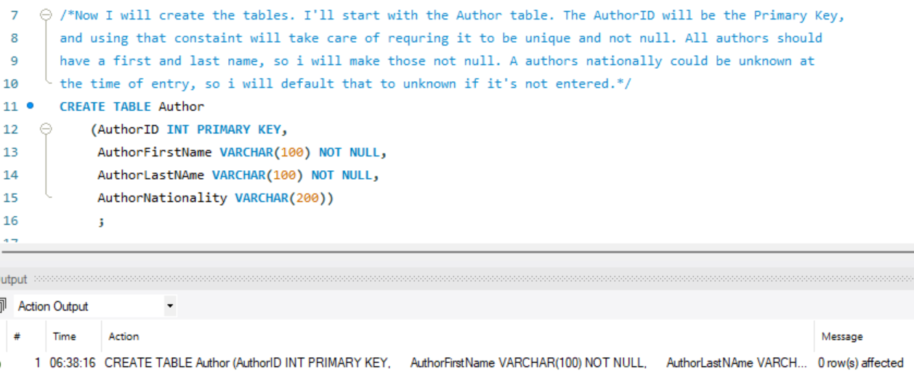

/* Next, I'll make the Book table. BookID will be the primary key. All books should have a visible title, so I will make that not null and also give it a larger number of characters since titles can be pretty long. AuthorID will eventually be a foreign key to the Author table, so I will make sure the data type matches, and it is not null. */

CREATE TABLE Book

(BookID INT PRIMARY KEY,

BookTitle VARCHAR(500) NOT NULL,

AuthorID INT NOT NULL,

Genre VARCHAR(100))

;

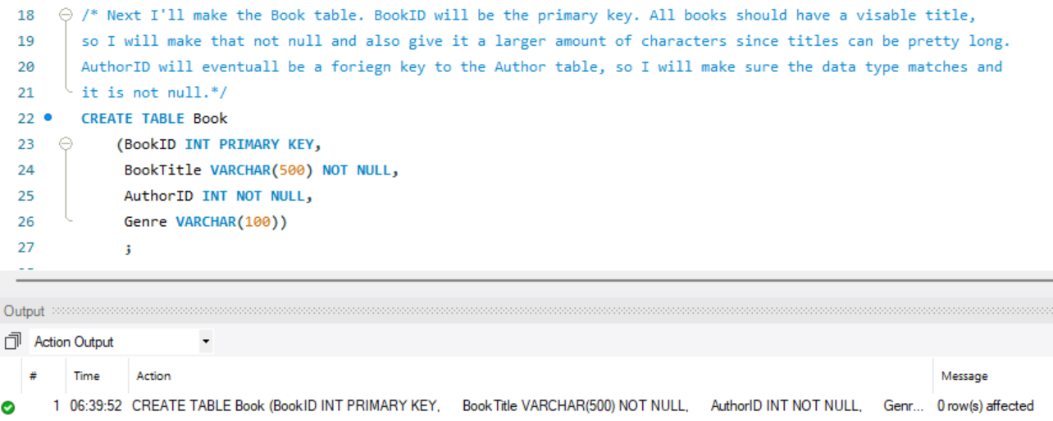

/*Next, I will make the borrower table. It looks like this table has its own intended primary key, BorrowID, so I don’t need to worry about making a primary key based on two columns. ClientID and BookID cannot be null, as there has to be someone borrowing and a book being borrowed - they will also be foreign keys so I will make sure the data types match. */

CREATE TABLE Borrower

(BorrowID INT PRIMARY KEY,

ClientID INT NOT NULL,

BookID INT NOT NULL,

BorrowDate DATE NOT NULL)

;

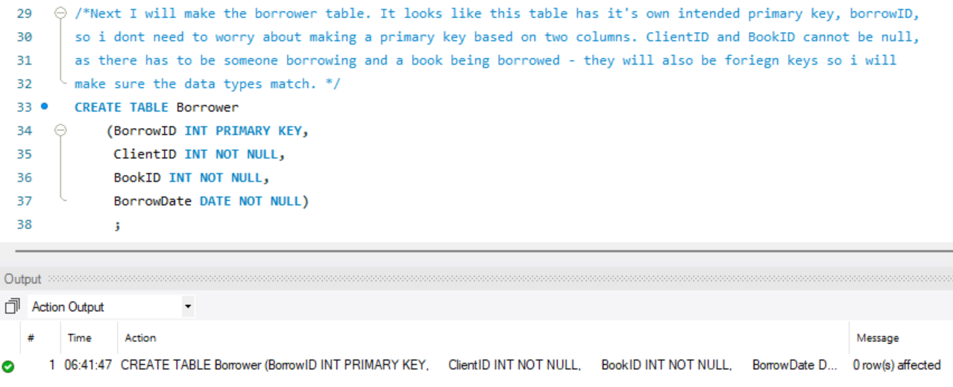

/*Last, I will make the Client table. ClientID will be the primary key. In the real world any piece of data could be missing from the Clients profile, but they will always be using their library card which would have their ClientID on it. Because of this I will not make these fields not null. The field ClientDOB looks like it only provides a year for the DOB so I will make that an INT column. */

CREATE TABLE Client

(ClientID INT PRIMARY KEY,

ClientFirstName VARCHAR(100),

ClientLastName VARCHAR(100),

ClientDOB INT,

Occupation VARCHAR(200))

;

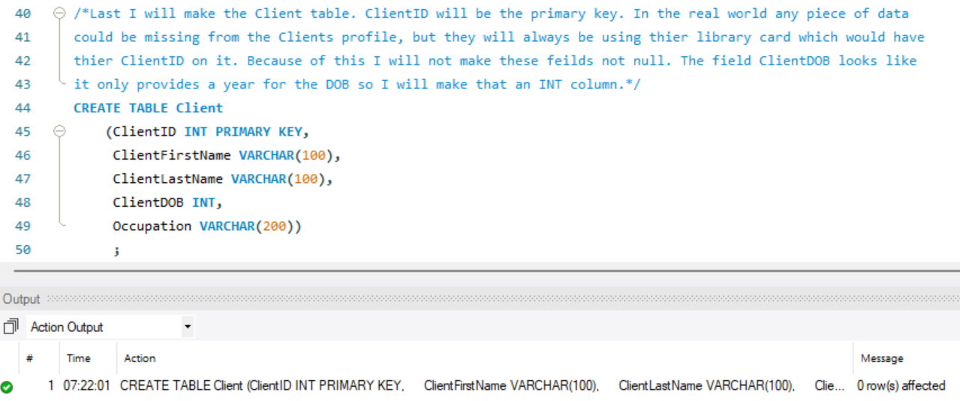

/*Now that the tables are made, I need to create the relationships between them.

AuthorID in the Book table is a foreign key to AuthorID in the Author table. One author can write many books. */

ALTER TABLE BOOK

ADD CONSTRAINT author_forkey FOREIGN KEY (AuthorID)

REFERENCES Author (AuthorID)

;

/*Next, I will add a foreign key from the Borrower table, BookID, to the Book table, BookID*/

ALTER TABLE Borrower

ADD CONSTRAINT book_forkey FOREIGN KEY (BookID)

REFERENCES Book (BookID)

;

/*Next there is another foreign key from the Borrower table, ClientID to the Client table, ClientID*/

ALTER TABLE Borrower

ADD CONSTRAINT client_forkey FOREIGN KEY (ClientID)

REFERENCES Client (ClientID)

;

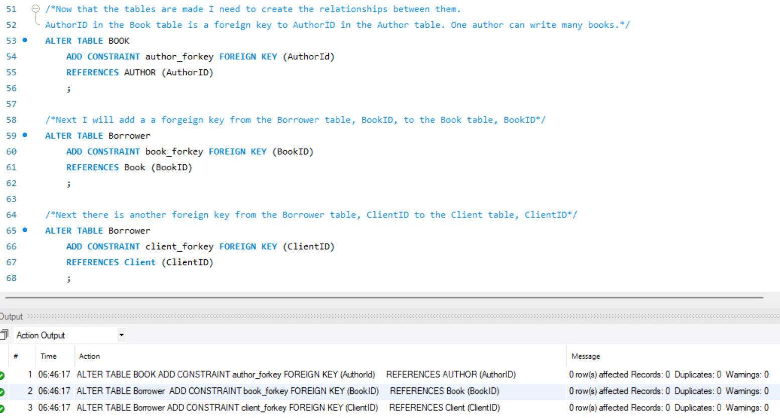

/*All tables have been created, have appropriate constraints, primary keys, and foreign keys. */

**Part B. Use the tables provided in the prompt to fill the public library database.**

/*Now I will add the data into my tables. To do this I copied the data into Excel and used the CONCAT function to wrap the data in the correct formatting. First, I will do the Author table. */

INSERT INTO Author (AuthorID, AuthorFirstName, AuthorLastName, AuthorNationality)

VALUES

(1, 'Sofia', 'Smith', 'Canada'),

(2, 'Maria', 'Brown', 'Brazil'),

(3, 'Elena', 'Martin', 'Mexico'),

(4, 'Zoe', 'Roy', 'France'),

(5, 'Sebastian', 'Lavoie', 'Canada'),

(6, 'Dylan', 'Garcia', 'Spain'),

(7, 'Ian', 'Cruz', 'Mexico'),

(8, 'Lucas', 'Smith', 'USA'),

(9, 'Fabian', 'Wilson', 'USA'),

(10, 'Liam', 'Taylor', 'Canada'),

(11, 'William', 'Thomas', 'Great Britain'),

(12, 'Logan', 'Moore', 'Canada'),

(13, 'Oliver', 'Martin', 'France'),

(14, 'Alysha', 'Thompson', 'Canada'),

(15, 'Isabelle', 'Lee', 'Canada'),

(16, 'Emily', 'Clark', 'USA'),

(17, 'John', 'Young', 'China'),

(18, 'David', 'Wright', 'Canada'),

(19, 'Thomas', 'Scott', 'Canada'),

(20, 'Helena', 'Adams', 'Canada'),

(21, 'Sofia', 'Carter', 'USA'),

(22, 'Liam', 'Parker', 'Canada'),

(23, 'Emily', 'Murphy', 'USA')

;

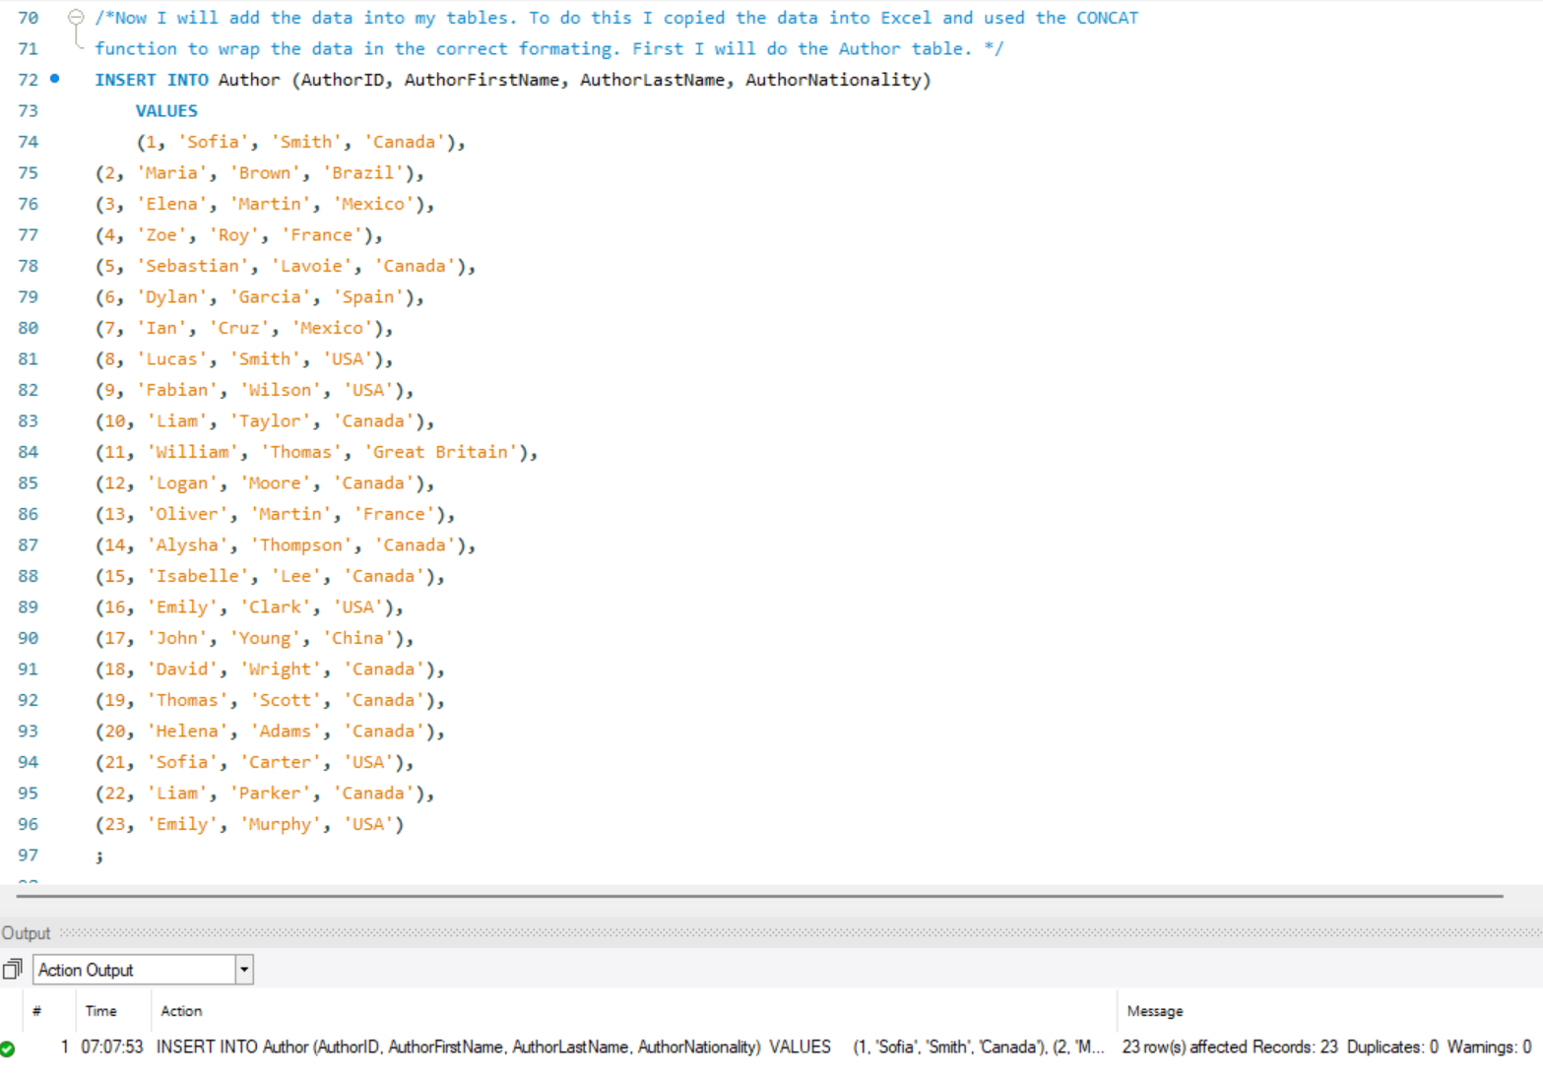

/*Now I will add the data into the Book table. There are two INT columns in this table so I

will make sure not to wrap those in quotations. */

INSERT INTO Book (BookID, BookTitle, AuthorID, Genre)

VALUES

(1, 'Build your database system', 1, 'Science'),

(2, 'The red wall', 2, 'Fiction'),

(3, 'The perfect match', 3, 'Fiction'),

(4, 'Digital Logic', 4, 'Science'),

(5, 'How to be a great lawyer', 5, 'Law'),

(6, 'Manage successful negotiations', 6, 'Society'),

(7, 'Pollution today', 7, 'Science'),

(8, 'A gray park', 2, 'Fiction'),

(9, 'How to be rich in one year', 8, 'Humor'),

(10, 'Their bright fate', 9, 'Fiction'),

(11, 'Black lines', 10, 'Fiction'),

(12, 'History of theater', 11, 'Literature'),

(13, 'Electrical transformers', 12, 'Science'),

(14, 'Build your big data system', 1, 'Science'),

(15, 'Right and left', 13, 'Children'),

(16, 'Programming using Python', 1, 'Science'),

(17, 'Computer networks', 14, 'Science'),

(18, 'Performance evaluation', 15, 'Science'),

(19, 'Daily exercise', 16, 'Well being'),

(20, 'The silver uniform', 17, 'Fiction'),

(21, 'Industrial revolution', 18, 'History'),

(22, 'Green nature', 19, 'Well being'),

(23, 'Perfect football', 20, 'Well being'),

(24, 'The chocolate love', 21, 'Humor'),

(25, 'Director and leader', 22, 'Society'),

(26, 'Play football every week', 20, 'well being'),

(27, 'Maya the bee', 13, 'Children'),

(28, 'Perfect rugby', 20, 'Well being'),

(29, 'The end', 23, 'Fiction'),

(30, 'Computer security', 1, 'Science'),

(31, 'Participate', 22, 'Society'),

(32, 'Positive figures', 3, 'Fiction')

;

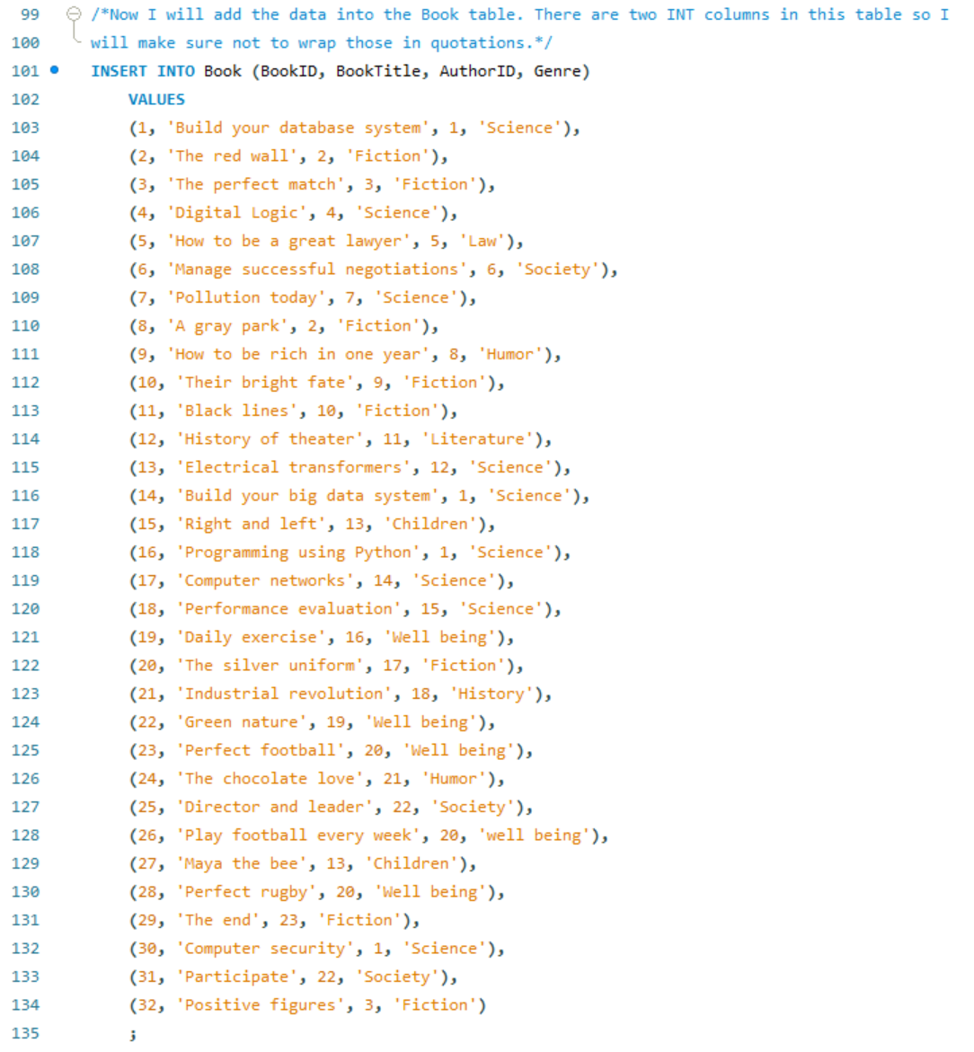



/*Now I will add data into the client table. ClientDOB is an INT field so I will not wrap that in quotes. There is a name with an apostrophe, to handle that I will add double apostrophes to indicate a single apostrophe in the string. */

INSERT INTO Client (ClientID, ClientFirstName, ClientLastName, ClientDOB, Occupation)

VALUES

(1, 'Kaiden', 'Hill', 2006, 'Student'),

(2, 'Alina', 'Morton', 2010, 'Student'),

(3, 'Fania', 'Brooks', 1983, 'Food Scientist'),

(4, 'Courtney', 'Jensen', 2006, 'Student'),

(5, 'Brittany', 'Hill', 1983, 'Firefighter'),

(6, 'Max', 'Rogers', 2005, 'Student'),

(7, 'Margaret', 'McCarthy', 1981, 'School Psychologist'),

(8, 'Julie', 'McCarthy', 1973, 'Professor'),

(9, 'Ken', 'McCarthy', 1974, 'Securities Clerk'),

(10, 'Britany', 'O''Quinn', 1984, 'Violinist'),

(11, 'Conner', 'Gardner', 1998, 'Licensed Massage Therapist'),

(12, 'Mya', 'Austin', 1960, 'Parquet Floor Layer'),

(13, 'Thierry', 'Rogers', 2004, 'Student'),

(14, 'Eloise', 'Rogers', 1984, 'Computer Security Manager'),

(15, 'Gerard', 'Jackson', 1979, 'Oil Exploration Engineer'),

(16, 'Randy', 'Day', 1986, 'Aircraft Electrician'),

(17, 'Jodie', 'Page', 1990, 'Manufacturing Director'),

(18, 'Coral', 'Rice', 1996, 'Window Washer'),

(19, 'Ayman', 'Austin', 2002, 'Student'),

(20, 'Jaxson', 'Austin', 1999, 'Repair Worker'),

(21, 'Joel', 'Austin', 1973, 'Police Officer'),

(22, 'Alina', 'Austin', 2010, 'Student'),

(23, 'Elin', 'Austin', 1962, 'Payroll Clerk'),

(24, 'Ophelia', 'Wolf', 2004, 'Student'),

(25, 'Eliot', 'McGuire', 1967, 'Dentist'),

(26, 'Peter', 'McKinney', 1968, 'Professor'),

(27, 'Annabella', 'Henry', 1974, 'Nurse'),

(28, 'Anastasia', 'Baker', 2001, 'Student'),

(29, 'Tyler', 'Baker', 1984, 'Police Officer'),

(30, 'Lilian', 'Ross', 1983, 'Insurance Agent'),

(31, 'Thierry', 'Arnold', 1975, 'Bus Driver'),

(32, 'Angelina', 'Rowe', 1979, 'Firefighter'),

(33, 'Marcia', 'Rowe', 1974, 'Health Educator'),

(34, 'Martin', 'Rowe', 1976, 'Ship Engineer'),

(35, 'Adeline', 'Rowe', 2005, 'Student'),

(36, 'Colette', 'Rowe', 1963, 'Professor'),

(37, 'Diane', 'Clark', 1975, 'Payroll Clerk'),

(38, 'Caroline', 'Clark', 1960, 'Dentist'),

(39, 'Dalton', 'Clayton', 1982, 'Police Officer'),

(40, 'Steve', 'Clayton', 1990, 'Bus Driver'),

(41, 'Melanie', 'Clayton', 1987, 'Computer Engineer'),

(42, 'Alana', 'Wilson', 2007, 'Student'),

(43, 'Carson', 'Byrne', 1995, 'Food Scientist'),

(44, 'Conrad', 'Byrne', 2007, 'Student'),

(45, 'Ryan', 'Porter', 2008, 'Student'),

(46, 'Elin', 'Porter', 1978, 'Computer Programmer'),

(47, 'Tyler', 'Harvey', 2007, 'Student'),

(48, 'Arya', 'Harvey', 2008, 'Student'),

(49, 'Serena', 'Harvey', 1978, 'School Teacher'),

(50, 'Lilly', 'Franklin', 1976, 'Doctor'),

(51, 'Mai', 'Franklin', 1994, 'Dentist'),

(52, 'John', 'Franklin', 1999, 'Firefighter'),

(53, 'Judy', 'Franklin', 1995, 'Firefighter'),

(54, 'Katy', 'Lloyd', 1992, 'School Teacher'),

(55, 'Tamara', 'Allen', 1963, 'Ship Engineer'),

(56, 'Maxim', 'Lyons', 1985, 'Police Officer'),

(57, 'Allan', 'Lyons', 1983, 'Computer Engineer'),

(58, 'Marc', 'Harris', 1980, 'School Teacher'),

(59, 'Elin', 'Young', 2009, 'Student'),

(60, 'Diana', 'Young', 2008, 'Student'),

(61, 'Diane', 'Young', 2006, 'Student'),

(62, 'Alana', 'Bird', 2003, 'Student'),

(63, 'Anna', 'Becker', 1979, 'Security Agent'),

(64, 'Katie', 'Grant', 1977, 'Manager'),

(65, 'Joan', 'Grant', 2010, 'Student'),

(66, 'Bryan', 'Bell', 2001, 'Student'),

(67, 'Belle', 'Miller', 1970, 'Professor'),

(68, 'Peggy', 'Stevens', 1990, 'Bus Driver'),

(69, 'Steve', 'Williamson', 1975, 'HR Clerk'),

(70, 'Tyler', 'Williamson', 1999, 'Doctor'),

(71, 'Izabelle', 'Williamson', 1990, 'Systems Analyst'),

(72, 'Annabel', 'Williamson', 1960, 'Cashier'),

(73, 'Mohamed', 'Waters', 1966, 'Insurance Agent'),

(74, 'Marion', 'Newman', 1970, 'Computer Programmer'),

(75, 'Ada', 'Williams', 1986, 'Computer Programmer'),

(76, 'Sean', 'Scott', 1983, 'Bus Driver'),

(77, 'Farrah', 'Scott', 1974, 'Ship Engineer'),

(78, 'Christine', 'Lambert', 1973, 'School Teacher'),

(79, 'Alysha', 'Lambert', 2007, 'Student'),

(80, 'Maia', 'Grant', 1984, 'School Teacher')

; 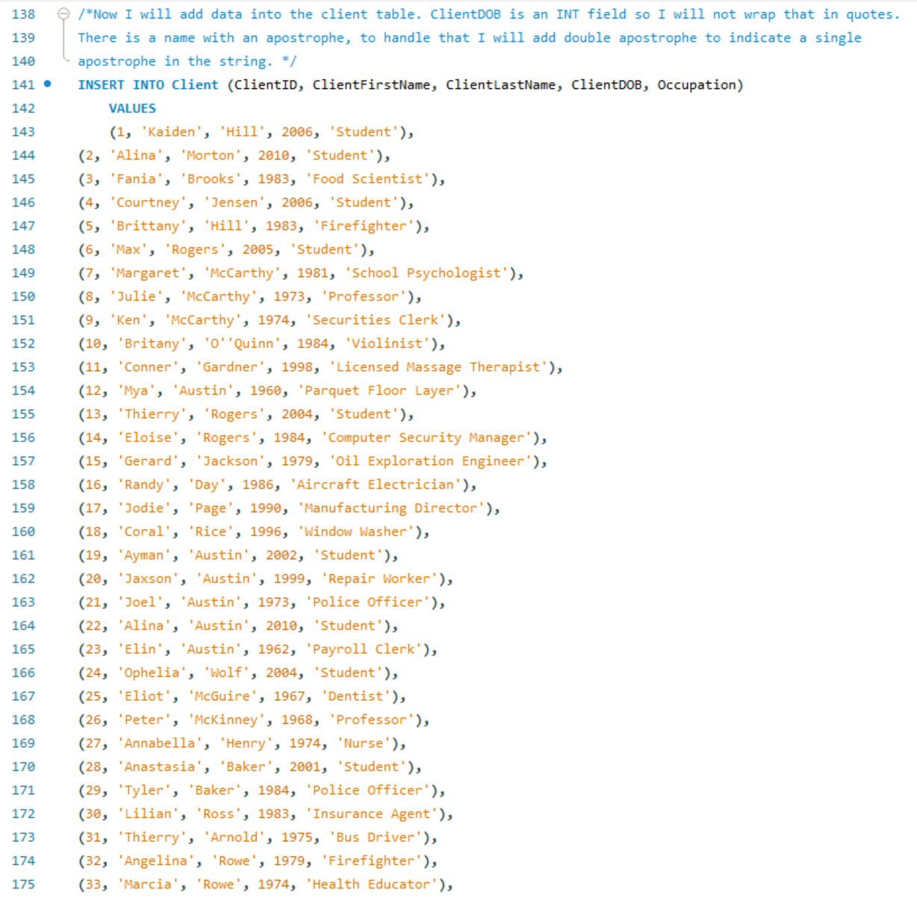

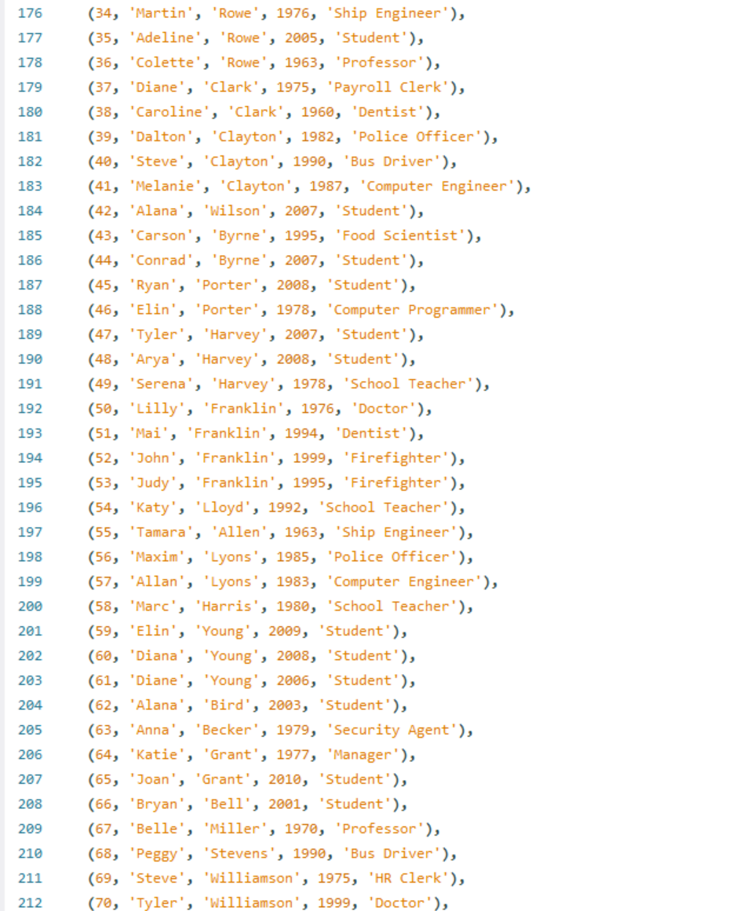

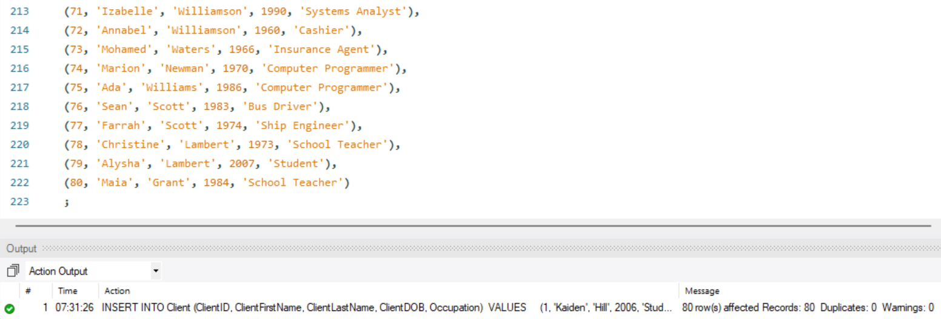

/*Now I will add data into the final table, Borrower. SQL stores dates in the format

YYYY-MM-DD so I have formatted by dates to be in that order and wrapped them in quotes.

MYSQL gave me a warning that '/' is deprecated and it prefers '-' so I will use that

instead. */

INSERT INTO Borrower (BorrowID, ClientID, BookID, BorrowDate)

VALUES

(1, 35, 17, '2016-07-20'),

(2, 1, 3, '2017-04-19'),

(3, 42, 8, '2016-10-03'),

(4, 62, 16, '2016-04-05'),

(5, 53, 13, '2017-01-17'),

(6, 33, 15, '2015-11-26'),

(7, 40, 14, '2015-01-21'),

(8, 64, 2, '2017-09-10'),

(9, 56, 30, '2017-08-02'),

(10, 23, 2, '2018-06-28'),

(11, 46, 19, '2015-11-18'),

(12, 61, 20, '2015-11-24'),

(13, 58, 7, '2017-06-17'),

(14, 46, 16, '2017-02-12'),

(15, 80, 21, '2018-03-18'),

(16, 51, 23, '2015-09-01'),

(17, 49, 18, '2015-07-28'),

(18, 43, 18, '2015-11-04'),

(19, 30, 2, '2018-08-10'),

(20, 48, 24, '2015-05-13'),

(21, 71, 5, '2016-09-05'),

(22, 35, 3, '2016-07-03'),

(23, 57, 1, '2015-03-17'),

(24, 23, 25, '2017-08-16'),

(25, 20, 12, '2018-07-24'),

(26, 25, 7, '2015-01-31'),

(27, 72, 29, '2016-04-10'),

(28, 74, 20, '2017-07-31'),

(29, 53, 14, '2016-02-20'),

(30, 32, 10, '2017-07-24'),

(31, 12, 15, '2018-04-25'),

(32, 77, 13, '2017-06-09'),

(33, 30, 4, '2017-10-24'),

(34, 37, 24, '2016-01-14'),

(35, 27, 26, '2017-06-05'),

(36, 1, 16, '2018-05-06'),

(37, 21, 9, '2016-03-19'),

(38, 69, 28, '2017-03-29'),

(39, 17, 19, '2017-03-14'),

(40, 8, 9, '2016-04-22'),

(41, 63, 18, '2015-01-25'),

(42, 65, 20, '2016-10-10'),

(43, 51, 19, '2015-07-28'),

(44, 23, 12, '2017-01-25'),

(45, 17, 4, '2017-04-18'),

(46, 68, 5, '2016-09-06'),

(47, 46, 13, '2017-09-30'),

(48, 15, 13, '2017-07-05'),

(49, 11, 19, '2017-12-14'),

(50, 78, 15, '2017-01-26'),

(51, 47, 9, '2015-03-03'),

(52, 68, 7, '2016-05-26'),

(53, 37, 26, '2017-02-06'),

(54, 48, 27, '2015-12-30'),

(55, 9, 21, '2017-10-21'),

(56, 29, 8, '2018-04-01'),

(57, 64, 18, '2017-08-29'),

(58, 61, 26, '2018-02-21'),

(59, 39, 28, '2016-07-26'),

(60, 73, 18, '2018-08-22'),

(61, 11, 13, '2018-01-17'),

(62, 45, 6, '2016-07-20'),

(63, 33, 13, '2018-03-18'),

(64, 10, 17, '2016-06-06'),

(65, 28, 18, '2017-02-17'),

(66, 51, 3, '2016-12-09'),

(67, 29, 2, '2015-09-18'),

(68, 28, 30, '2017-09-14'),

(69, 74, 20, '2015-12-12'),

(70, 15, 22, '2015-01-14'),

(71, 57, 8, '2017-08-20'),

(72, 2, 5, '2015-01-18'),

(73, 74, 12, '2018-04-14'),

(74, 51, 10, '2016-02-25'),

(75, 25, 17, '2015-02-24'),

(76, 45, 21, '2017-02-10'),

(77, 27, 25, '2016-08-03'),

(78, 32, 28, '2016-06-15'),

(79, 71, 21, '2017-05-21'),

(80, 75, 26, '2016-05-03'),

(81, 56, 32, '2015-12-23'),

(82, 26, 32, '2015-05-16'),

(83, 66, 32, '2015-05-30'),

(84, 57, 18, '2017-09-15'),

(85, 40, 15, '2016-09-02'),

(86, 65, 4, '2017-08-17'),

(87, 54, 7, '2015-12-19'),

(88, 29, 4, '2017-07-22'),

(89, 44, 9, '2017-12-31'),

(90, 56, 31, '2015-06-13'),

(91, 17, 4, '2015-04-01'),

(92, 35, 16, '2018-07-19'),

(93, 22, 18, '2017-06-22'),

(94, 39, 24, '2015-05-29'),

(95, 63, 14, '2018-01-20'),

(96, 53, 21, '2016-07-31'),

(97, 40, 9, '2016-07-10'),

(98, 52, 4, '2017-04-05'),

(99, 27, 20, '2016-09-04'),

(100, 72, 29, '2015-12-06'),

(101, 49, 16, '2017-12-19'),

(102, 6, 12, '2016-12-04'),

(103, 74, 31, '2016-07-27'),

(104, 48, 32, '2016-06-29'),

(105, 69, 2, '2016-12-27'),

(106, 60, 32, '2017-10-29'),

(107, 45, 22, '2017-06-12'),

(108, 42, 15, '2017-05-14'),

(109, 79, 8, '2016-10-13'),

(110, 70, 18, '2016-12-04'),

(111, 34, 8, '2016-03-06'),

(112, 43, 8, '2015-12-19'),

(113, 42, 32, '2016-04-20'),

(114, 67, 5, '2017-03-06'),

(115, 80, 25, '2015-06-23'),

(116, 54, 11, '2017-05-03'),

(117, 34, 28, '2017-08-30'),

(118, 65, 20, '2017-08-26'),

(119, 61, 19, '2018-01-05'),

(120, 38, 12, '2018-01-17'),

(121, 51, 4, '2016-05-13'),

(122, 7, 16, '2016-03-17'),

(123, 46, 16, '2016-11-25'),

(124, 75, 30, '2018-08-12'),

(125, 72, 32, '2015-03-12'),

(126, 44, 17, '2015-06-15'),

(127, 68, 15, '2016-02-21'),

(128, 21, 1, '2016-06-19'),

(129, 14, 25, '2016-10-10'),

(130, 68, 21, '2016-05-27'),

(131, 35, 20, '2015-03-19'),

(132, 16, 27, '2016-08-08'),

(133, 79, 31, '2018-03-07'),

(134, 14, 17, '2018-04-28'),

(135, 29, 28, '2018-03-11'),

(136, 41, 4, '2018-08-08'),

(137, 42, 3, '2016-02-23'),

(138, 45, 3, '2017-07-10'),

(139, 36, 16, '2018-07-19'),

(140, 36, 30, '2015-08-07'),

(141, 54, 32, '2018-03-14'),

(142, 61, 15, '2017-03-28'),

(143, 1, 13, '2018-05-17'),

(144, 43, 1, '2015-05-14'),

(145, 37, 14, '2015-07-30'),

(146, 62, 17, '2015-09-19'),

(147, 50, 22, '2016-12-02'),

(148, 45, 1, '2016-07-24'),

(149, 32, 17, '2018-03-10'),

(150, 13, 28, '2016-02-14'),

(151, 15, 9, '2018-08-11'),

(152, 10, 19, '2018-08-29'),

(153, 66, 3, '2016-11-27'),

(154, 68, 29, '2017-07-12'),

(155, 21, 14, '2018-06-27'),

(156, 35, 9, '2016-01-22'),

(157, 17, 24, '2016-08-25'),

(158, 40, 21, '2015-07-09'),

(159, 1, 24, '2016-03-28'),

(160, 70, 27, '2015-07-10'),

(161, 80, 26, '2016-04-24'),

(162, 29, 5, '2015-10-18'),

(163, 76, 12, '2018-04-25'),

(164, 22, 4, '2016-12-24'),

(165, 2, 2, '2017-10-26'),

(166, 35, 13, '2016-02-28'),

(167, 40, 8, '2017-10-02'),

(168, 68, 9, '2016-01-03'),

(169, 32, 5, '2016-11-13'),

(170, 34, 17, '2016-09-15'),

(171, 34, 16, '2018-04-13'),

(172, 80, 30, '2016-10-13'),

(173, 20, 32, '2015-11-17'),

(174, 36, 10, '2017-09-01'),

(175, 78, 12, '2018-06-27'),

(176, 57, 8, '2016-03-22'),

(177, 75, 11, '2017-06-27'),

(178, 71, 10, '2015-08-01'),

(179, 48, 22, '2015-09-29'),

(180, 19, 16, '2016-02-21'),

(181, 79, 30, '2018-08-20'),

(182, 70, 13, '2016-09-16'),

(183, 30, 6, '2017-02-10'),

(184, 45, 12, '2017-10-12'),

(185, 30, 27, '2016-11-23'),

(186, 26, 3, '2016-08-13'),

(187, 66, 6, '2017-01-14'),

(188, 47, 15, '2016-02-10'),

(189, 53, 30, '2018-08-08'),

(190, 80, 16, '2016-03-31'),

(191, 70, 13, '2018-02-03'),

(192, 14, 25, '2016-03-27'),

(193, 46, 22, '2016-01-13'),

(194, 30, 32, '2015-08-06'),

(195, 60, 14, '2016-11-27'),

(196, 14, 13, '2018-05-23'),

(197, 71, 15, '2016-06-22'),

(198, 38, 21, '2015-12-27'),

(199, 69, 30, '2017-04-29'),

(200, 49, 31, '2018-06-03'),

(201, 28, 28, '2015-05-29'),

(202, 49, 3, '2016-08-30'),

(203, 75, 1, '2015-10-29'),

(204, 78, 3, '2017-05-12'),

(205, 43, 18, '2015-03-25'),

(206, 27, 21, '2016-02-22'),

(207, 64, 22, '2015-04-03'),

(208, 21, 11, '2017-12-09'),

(209, 66, 29, '2016-12-20'),

(210, 45, 13, '2017-04-15'),

(211, 48, 30, '2015-01-31'),

(212, 20, 25, '2017-12-20'),

(213, 41, 20, '2018-01-29'),

(214, 51, 12, '2015-07-05'),

(215, 5, 1, '2015-04-12'),

(216, 40, 3, '2018-02-24'),

(217, 79, 4, '2018-06-27'),

(218, 15, 10, '2016-11-01'),

(219, 42, 22, '2016-12-28'),

(220, 17, 9, '2018-01-29'),

(221, 38, 13, '2016-05-09'),

(222, 79, 2, '2017-12-06'),

(223, 74, 3, '2015-12-07'),

(224, 46, 8, '2016-06-05'),

(225, 78, 22, '2018-08-11'),

(226, 45, 2, '2015-04-20'),

(227, 72, 31, '2015-11-11'),

(228, 18, 17, '2015-03-21'),

(229, 29, 3, '2017-08-13'),

(230, 66, 11, '2018-06-05'),

(231, 36, 16, '2016-04-28'),

(232, 26, 2, '2016-10-23'),

(233, 32, 1, '2017-10-31'),

(234, 62, 14, '2017-07-25'),

(235, 12, 4, '2015-07-08'),

(236, 38, 32, '2015-02-24'),

(237, 29, 16, '2016-07-28'),

(238, 36, 25, '2017-05-07'),

(239, 76, 7, '2015-06-13'),

(240, 28, 16, '2016-08-15'),

(241, 60, 13, '2016-08-26'),

(242, 8, 3, '2017-07-28'),

(243, 25, 1, '2016-07-30'),

(244, 62, 29, '2018-08-24'),

(245, 51, 8, '2016-09-01'),

(246, 27, 23, '2015-02-08'),

(247, 69, 12, '2018-06-25'),

(248, 51, 12, '2015-07-04'),

(249, 7, 4, '2015-05-01'),

(250, 31, 15, '2017-10-29'),

(251, 14, 23, '2015-01-15'),

(252, 14, 1, '2018-05-21'),

(253, 39, 25, '2015-12-26'),

(254, 79, 24, '2016-05-31'),

(255, 40, 15, '2016-03-18'),

(256, 51, 13, '2018-04-13'),

(257, 61, 1, '2015-02-11'),

(258, 15, 24, '2018-03-02'),

(259, 10, 22, '2018-01-21'),

(260, 67, 10, '2017-07-08'),

(261, 79, 11, '2016-12-11'),

(262, 19, 32, '2016-05-04'),

(263, 35, 11, '2017-08-01'),

(264, 27, 13, '2017-12-15'),

(265, 30, 22, '2015-12-22'),

(266, 8, 7, '2015-06-26'),

(267, 70, 9, '2016-03-20'),

(268, 56, 18, '2016-01-29'),

(269, 13, 19, '2015-03-06'),

(270, 61, 2, '2016-06-18'),

(271, 47, 13, '2017-09-18'),

(272, 30, 22, '2016-02-19'),

(273, 18, 22, '2016-12-31'),

(274, 34, 29, '2017-10-27'),

(275, 32, 21, '2015-06-03'),

(276, 9, 28, '2016-03-30'),

(277, 62, 24, '2015-03-23'),

(278, 44, 22, '2017-04-29'),

(279, 27, 5, '2015-03-25'),

(280, 61, 28, '2017-07-14'),

(281, 5, 13, '2016-12-04'),

(282, 43, 19, '2018-03-15'),

(283, 34, 19, '2016-06-05'),

(284, 35, 5, '2018-02-19'),

(285, 13, 12, '2016-09-23'),

(286, 74, 18, '2016-12-26'),

(287, 70, 31, '2017-08-15'),

(288, 42, 17, '2016-06-15'),

(289, 51, 24, '2018-07-30'),

(290, 45, 30, '2015-01-15'),

(291, 70, 17, '2017-10-07'),

(292, 77, 7, '2017-01-06'),

(293, 74, 25, '2015-09-25'),

(294, 47, 14, '2018-02-01'),

(295, 10, 2, '2017-04-18'),

(296, 16, 21, '2016-10-03'),

(297, 48, 5, '2016-09-17'),

(298, 72, 3, '2017-02-10'),

(299, 26, 23, '2016-03-01'),

(300, 49, 23, '2016-10-25')

;

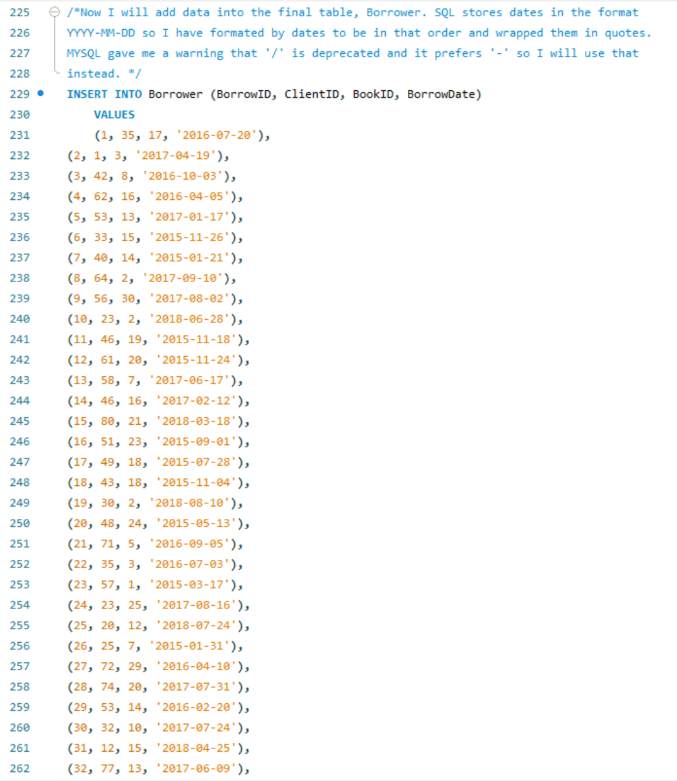



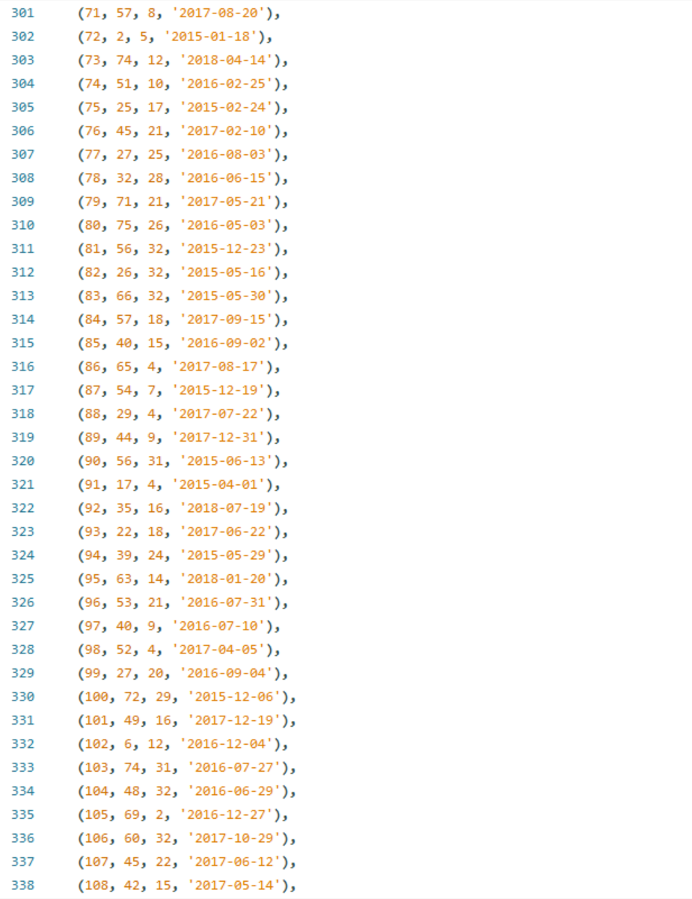

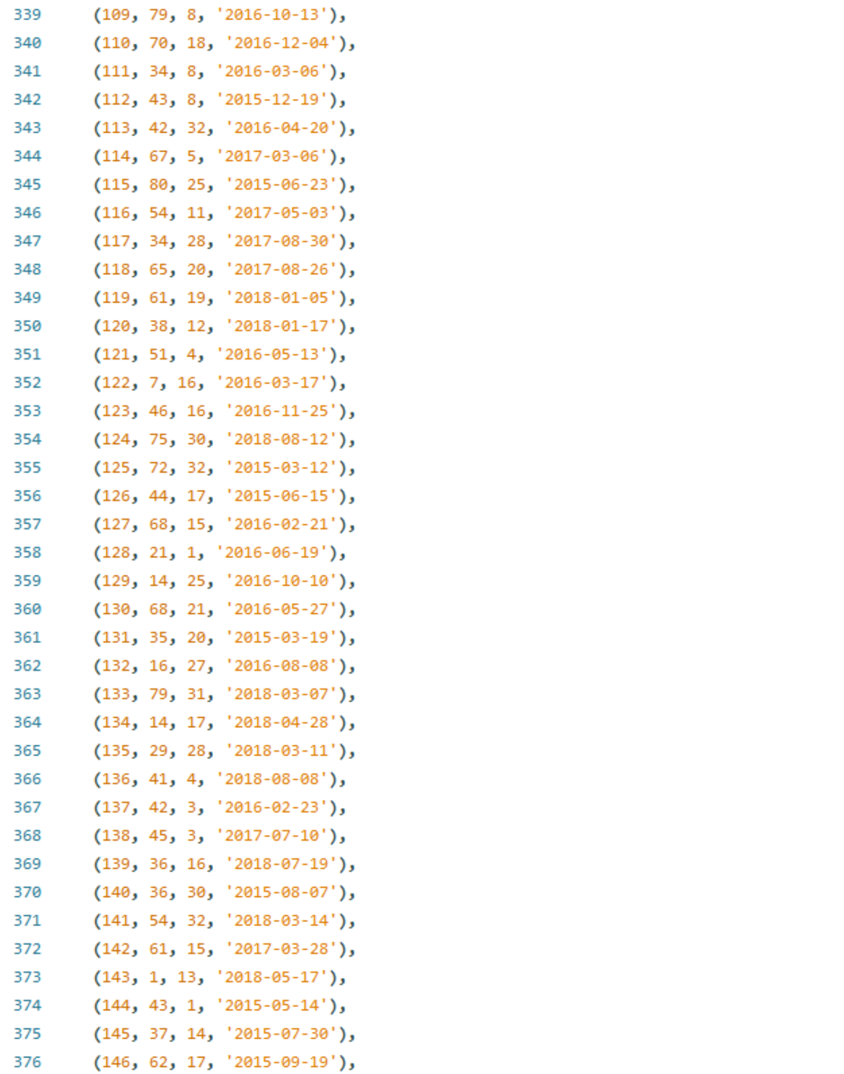

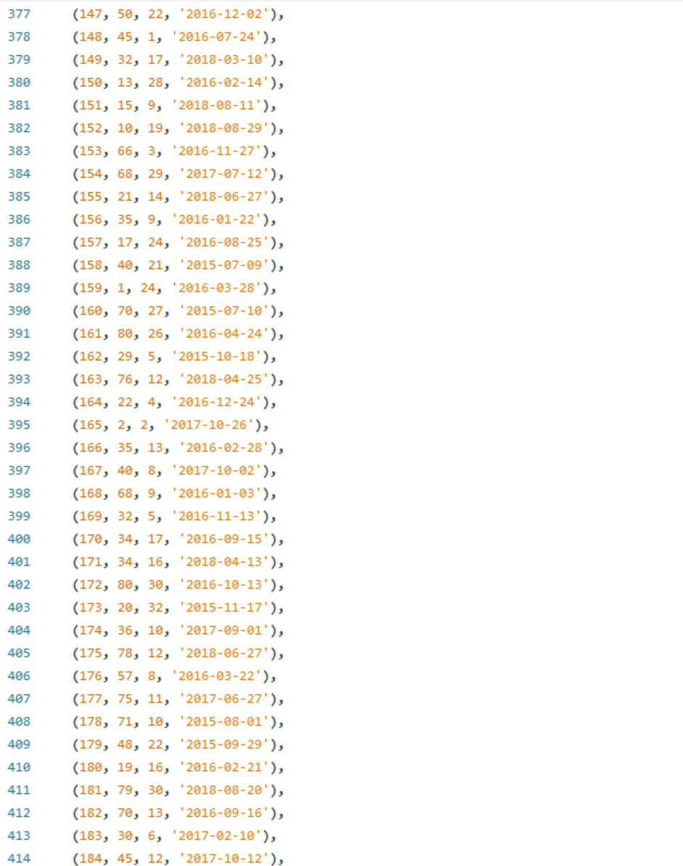

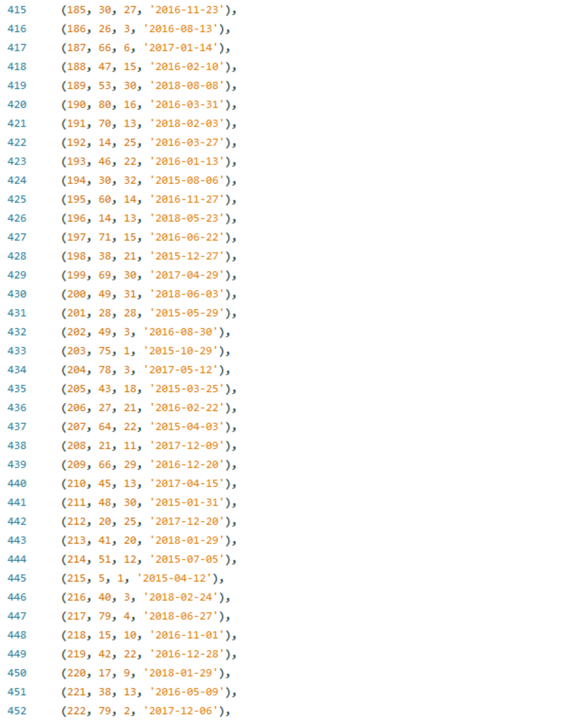

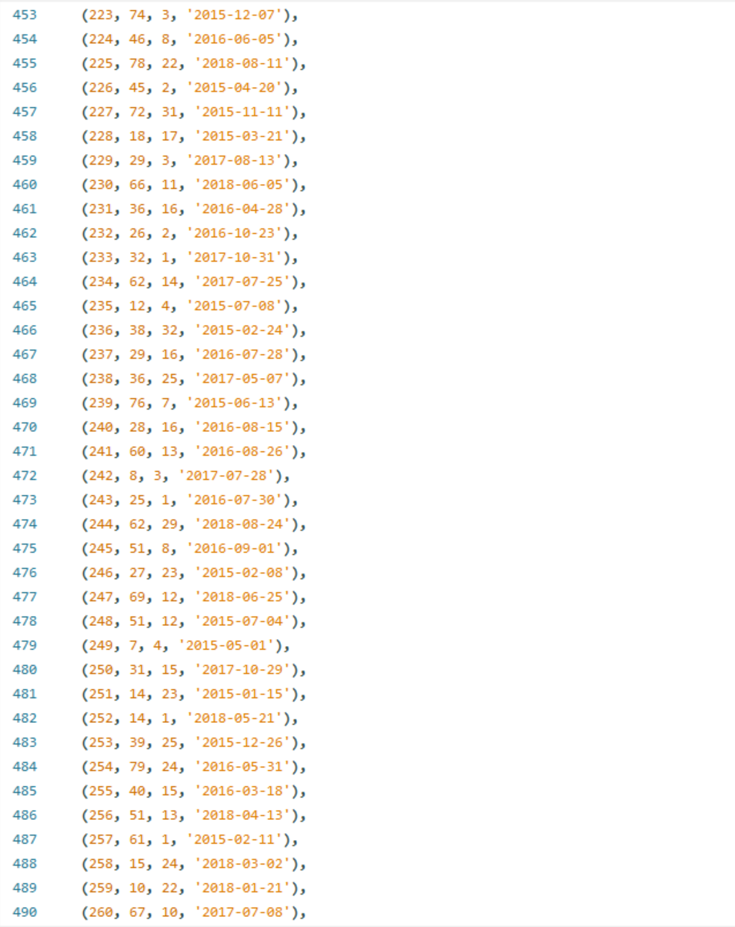

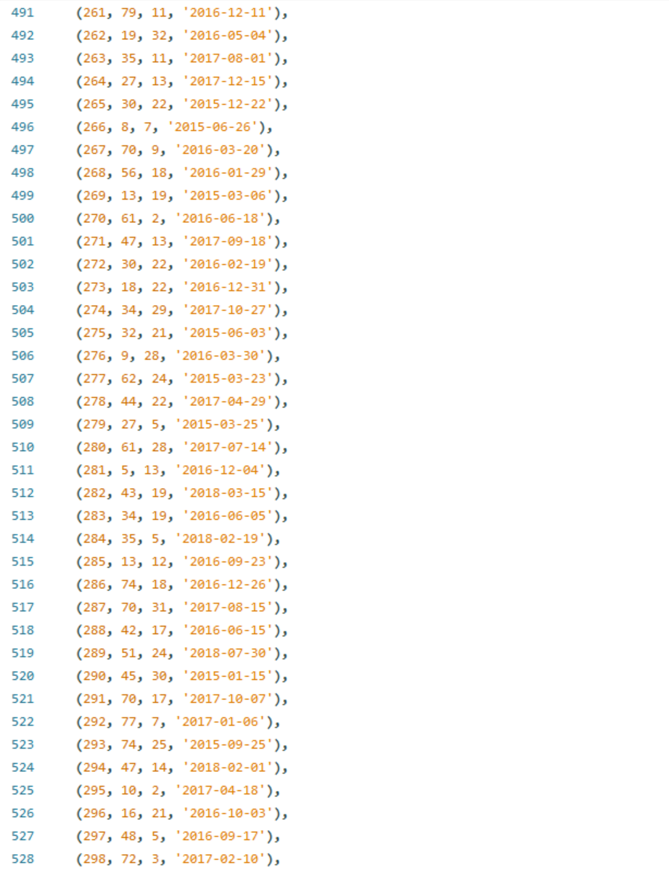

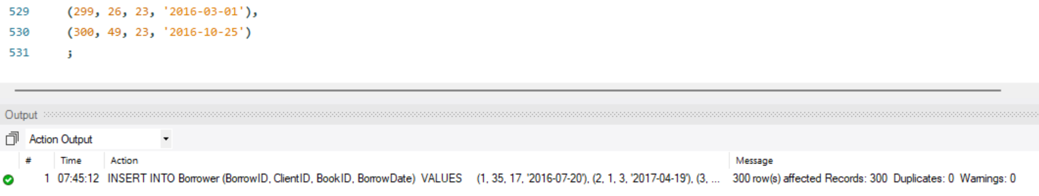

**Part C. Create queries for each of the fourteen questions in the assignment.**

1. **Display all contents of the Clients table**

/*To display everything in the Clients table I will do a simple select all. */

SELECT *

FROM Client ;

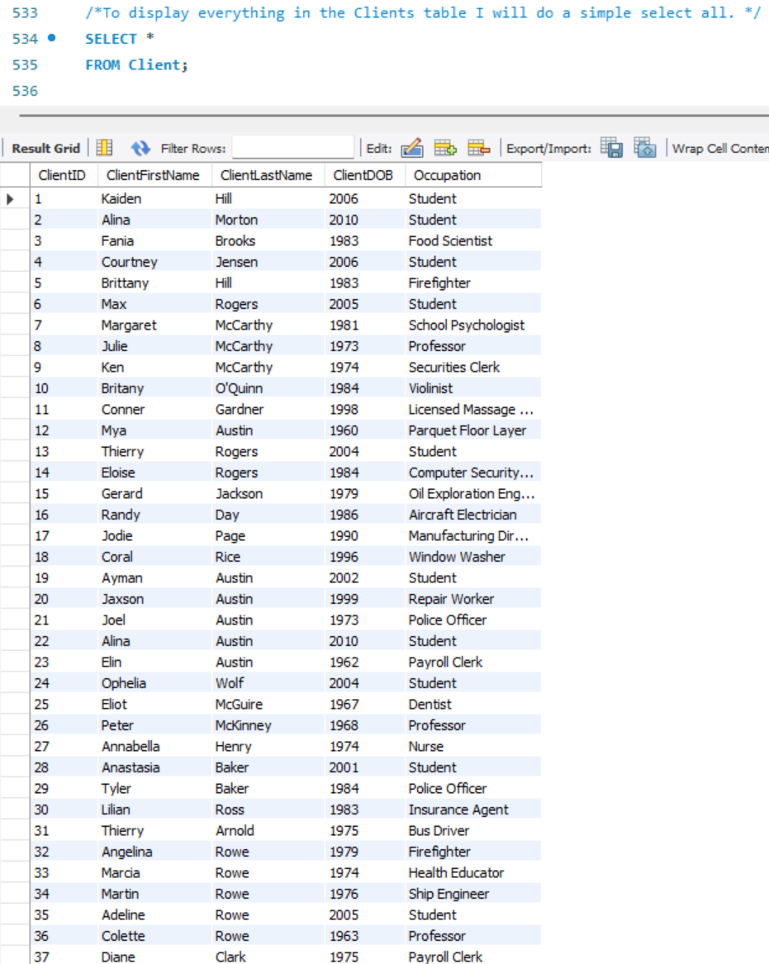

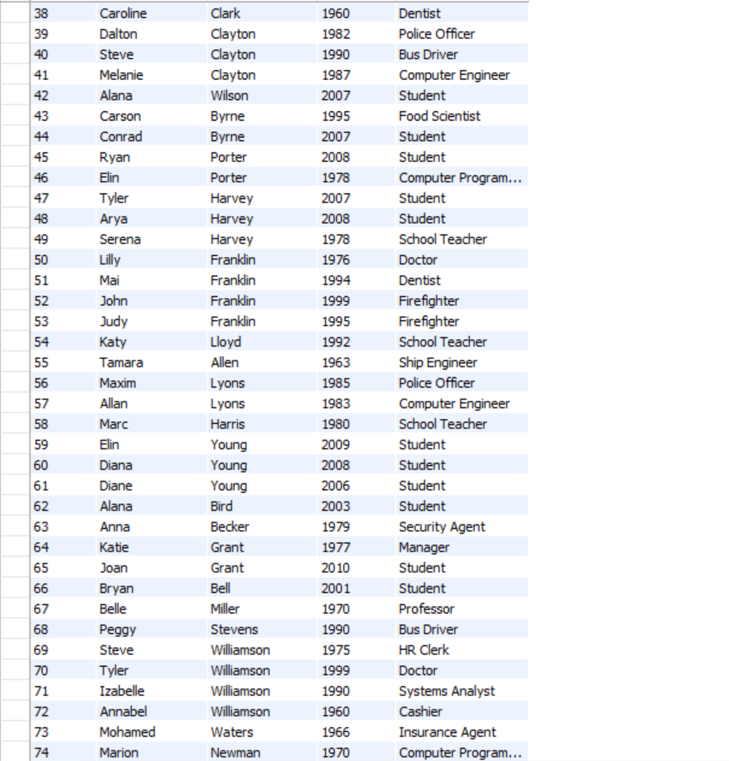

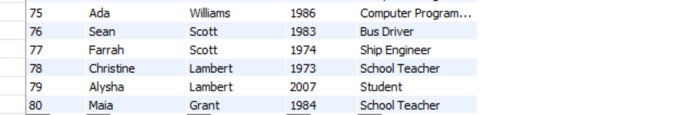

1. **First names, last names, ages and occupations of all clients**

/*First, I'll select the client’s first name and last name. Then to show their age I need to do some math. I will subtract the current year, 2025, from the year they were born, ClientDOB. This of course will not be their exact age on this very day since we do not know the month and day of their date of birth. */

SELECT

cln.ClientFirstName

,cln.ClientLastName

,(2025 - cln.ClientDOB) AS ClientAge

,cln.Occupation

FROM Client cln

;

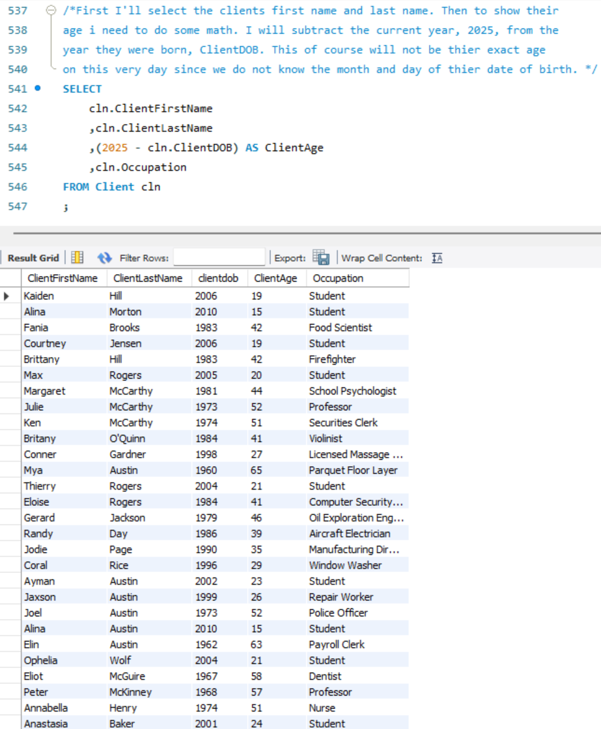

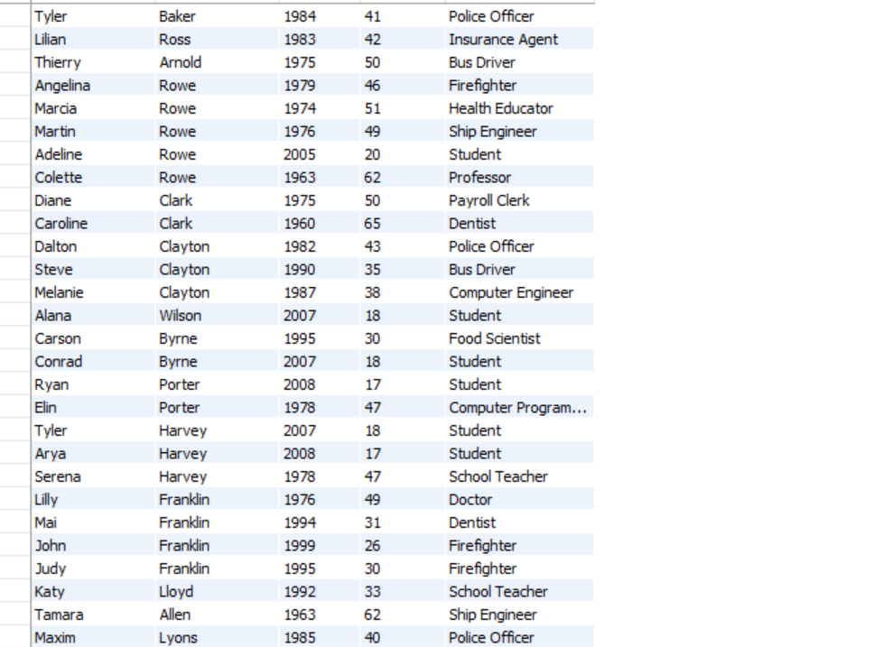

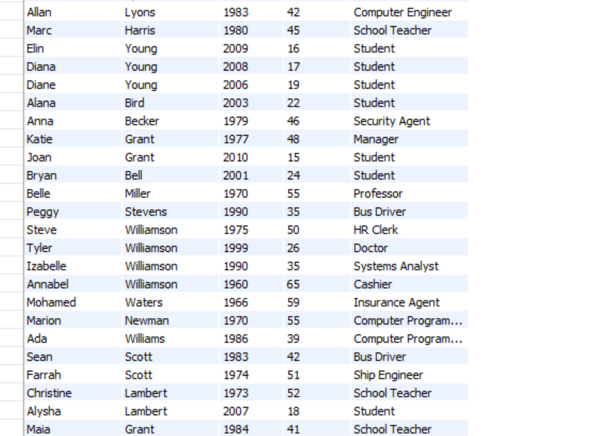

1. **First and last names of clients that borrowed books in March 2018**

/*To get clients who borrowed books in March 2019 I need to join the Clients table to the Borrower table. I will do this on the borrower tables foreign key ClientID To get the correct borrow date I will look for borrow dates with a year of 2018 and a month of 3 (March). Alternatively you could do brw.borrowDate >= '2018-03-01 AND brw.borrowDate < '2018-04-01 */

SELECT

cln.ClientFirstName

,cln.ClientLastName

FROM

Client cln

INNER JOIN Borrower brw ON cln.ClientID = brw.ClientID

WHERE

YEAR(brw.BorrowDate) = 2018

AND MONTH(brw.BorrowDate) = 3

;

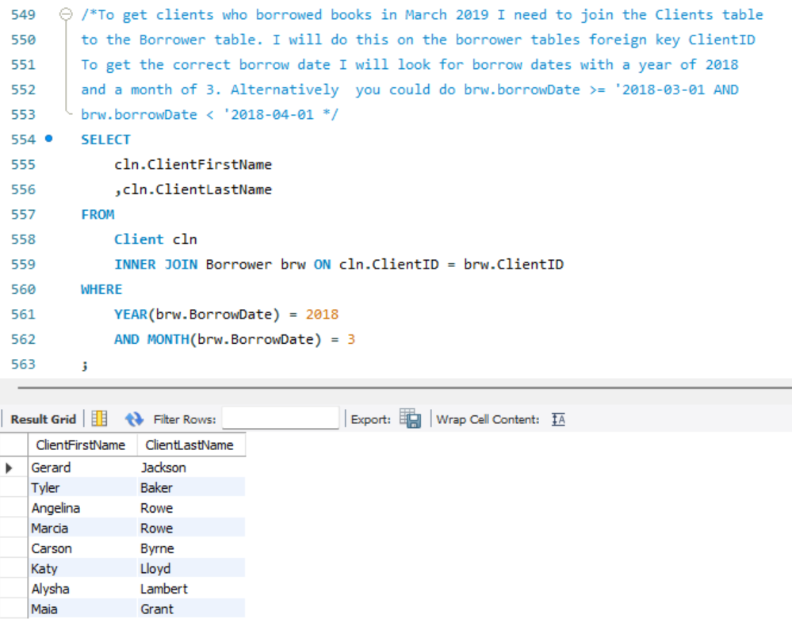

1. **First and last names of the top 5 authors clients borrowed in 2017**

/*To get the top 5 authors that clients borrow in 2017 I need to rank the authors by number of borrows. First I will limit the borrow dates to only ones that occurred in 2017. Then I will group by authorID since that is more straight forward then both the first and last name columns, where two authors could potentially have the same last name. Then I will order by the amount of borrowing that author had, in descending order so the most borrowed are at the top of the list. Then I'll limit it to five results. */

SELECT

ath.AuthorFirstName

,ath.AuthorLastName

FROM

Borrower brw

LEFT JOIN Book bk ON brw.BookId = bk.BookId

LEFT JOIN Author ath ON bk.AuthorID = ath.AuthorID

WHERE

YEAR(brw.BorrowDate) = 2017

GROUP BY bk.AuthorID

ORDER BY COUNT(brw.BorrowID) DESC

LIMIT 5

;

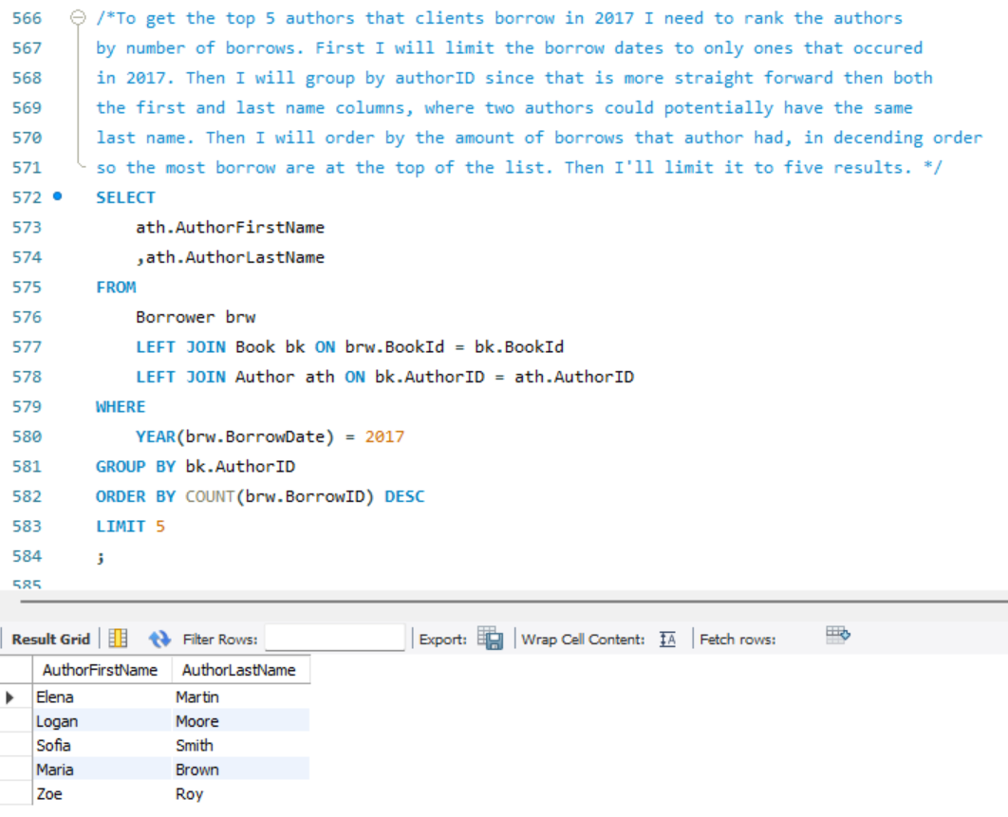

1. **Nationalities of the least 5 authors that clients borrowed during the years 2015-2017**

/*To get the nationalities of the least five authors that clients borrowed from in 2015 to 2017 I will use a similar query to my last. I will sort by the count of borrowed books in ascending order (the default) to find the least amount borrowed. I will also make my date range to include 2015 up to 2017, then I will just select nationality. The question did not specify that it wanted distinct nationalities, but just the nationalities of the least 5 authors, so there can be duplicate nationalities in the results. */

SELECT

ath.AuthorNationality

FROM

Borrower brw

LEFT JOIN Book bk ON brw.BookId = bk.BookId

LEFT JOIN Author ath ON bk.AuthorID = ath.AuthorID

WHERE

YEAR(brw.BorrowDate) >= 2015

AND YEAR(brw.BorrowDate) <= 2017

GROUP BY bk.AuthorID

ORDER BY COUNT(brw.BorrowID)

LIMIT 5

;

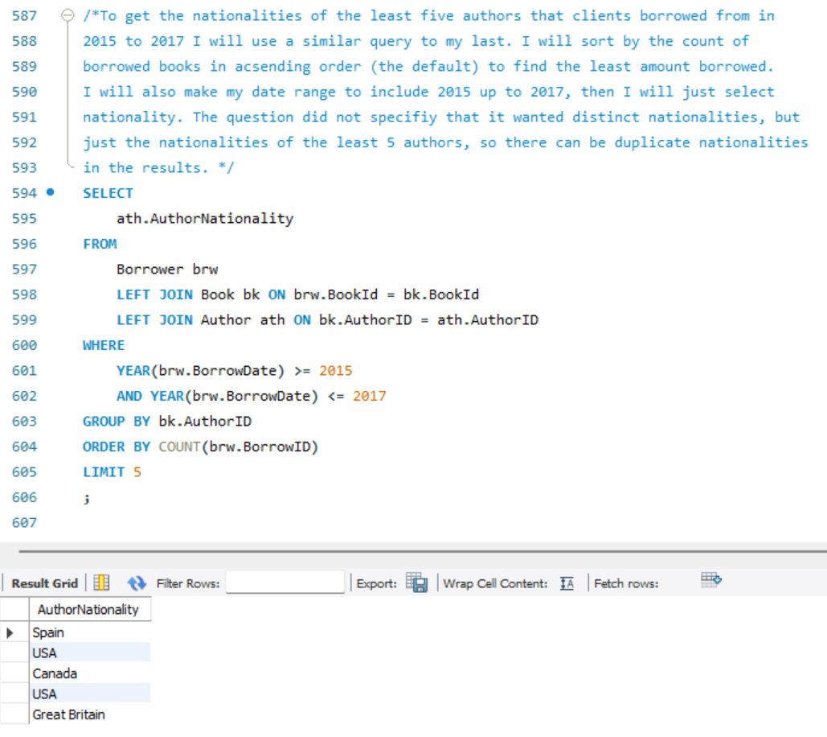

1. **The book that was most borrowed during the years 2015-2017**

/*To find the book that was the most borrowed in 2015 to 2017 I need to order by the count of books borrowed in descending order grouped by the book id. Then I need to limit my results to one book*/

SELECT

bk.BookTitle

FROM

Borrower brw

LEFT JOIN Book bk ON brw.BookId = bk.BookId

WHERE

YEAR(brw.BorrowDate) >= 2015

AND YEAR(brw.BorrowDate) <= 2017

GROUP BY bk.BookID

ORDER BY COUNT(brw.BorrowID) DESC

LIMIT 1

;

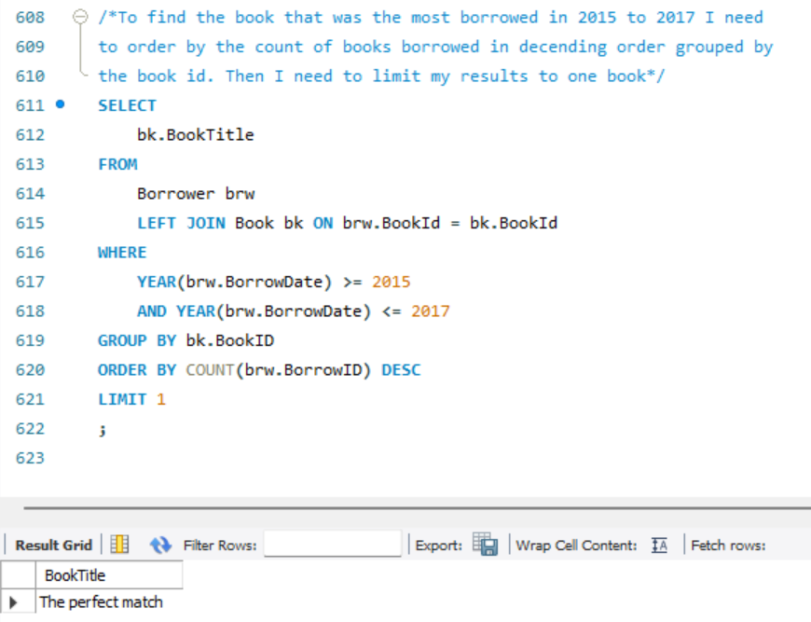

1. **Top borrowed genres for client born in years 1970-1980**

/*To find the top book genres that are borrowed by clients born from 1970 to 1980 I need to limit my results to only borrows that were from a client born in the year range. Then I need to group by genre and get a count of the borrows in each genre. The question did not specify how many genres to include so I will list them all in order from most popular to least. */

SELECT

bk.Genre

FROM

Borrower brw

LEFT JOIN Client cln ON brw.ClientID = cln.ClientID

LEFT JOIN Book bk ON brw.BookId = bk.BookId

WHERE

cln.ClientDOB >= 1970

AND cln.ClientDOB <= 1980

GROUP BY bk.Genre

ORDER BY COUNT(brw.BorrowID) DESC

;

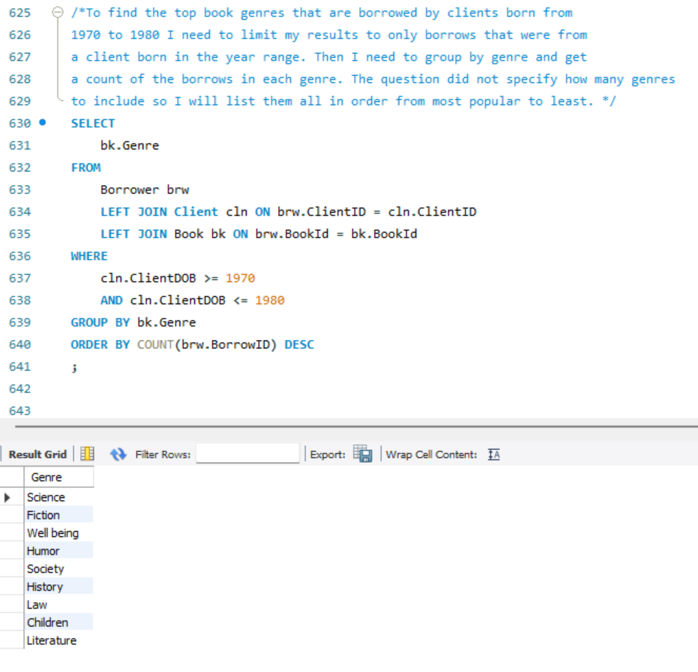

1. **Top 5 occupations that borrowed the most in 2016**

/*To find the top five occupations that borrowed the most in 2016 I will need to group by occupation, then order count of books borrowed per occupation in descending order to find the most. I will limit the borrow dates to only those in 2016 and limit to 5 results. */

SELECT

cln.Occupation

FROM

Borrower brw

LEFT JOIN Client cln ON brw.ClientID = cln.ClientID

WHERE

YEAR(brw.BorrowDate) = 2016

GROUP BY cln.Occupation

ORDER BY COUNT(brw.BorrowID) DESC

LIMIT 5

;

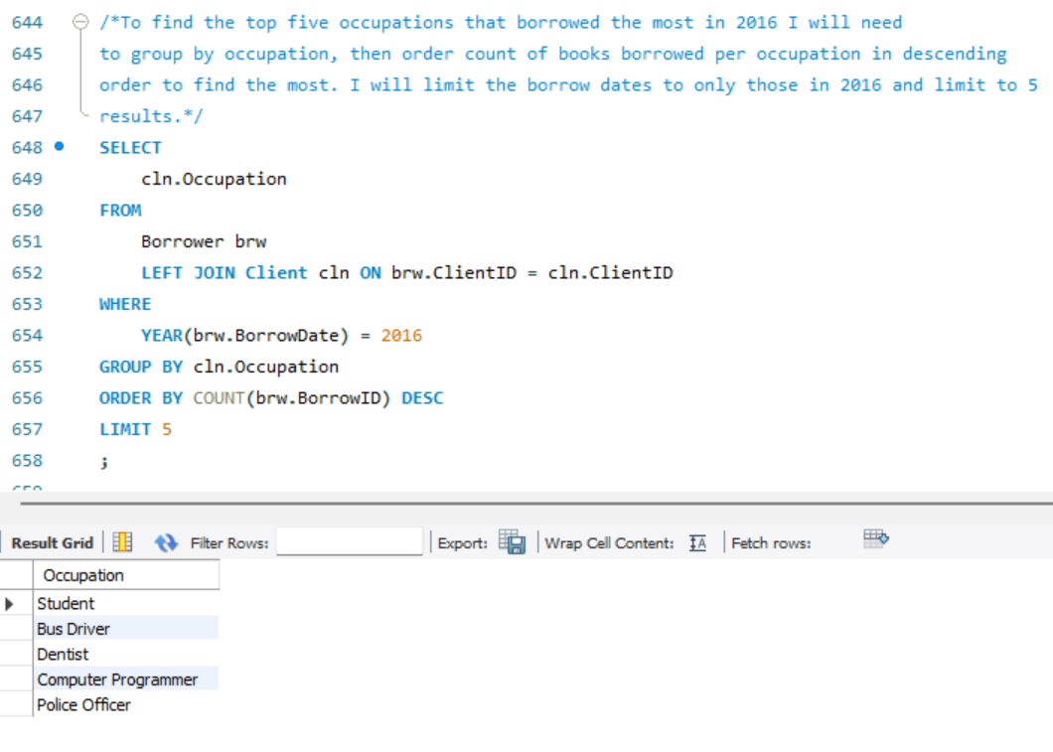

1. **Average number of borrowed books by job title**

/*To find the average number of books borrowed per person I am going to need a subquery. First, I need to find the number of books each person has borrowed, so I will group by ClientID and get the count of borrows. I included occupation here, so I don’t have to do another join to client in the main query. Now that I have the number of books each person has borrowed, I can group by occupation and get an average number of books. I rounded this to a whole number. No direction was given on order, so I did it from highest average to lowest. */

SELECT

BksPerPerson.Occupation AS Job_Title

,ROUND(AVG(BksPerPerson.Num_Borrowed_Books), 0) AS Avg_Books_Borrowed

FROM (

SELECT

cln.ClientID

,cln.Occupation

,COUNT(brw.BorrowID) AS Num_Borrowed_Books

FROM

Borrower brw

LEFT JOIN Client cln ON brw.ClientID = cln.ClientID

GROUP BY

cln.ClientID,

cln.Occupation

) BksPerPerson

GROUP BY BksPerPerson.Occupation

ORDER BY ROUND(AVG(BksPerPerson.Num_Borrowed_Books), 0) DESC

;

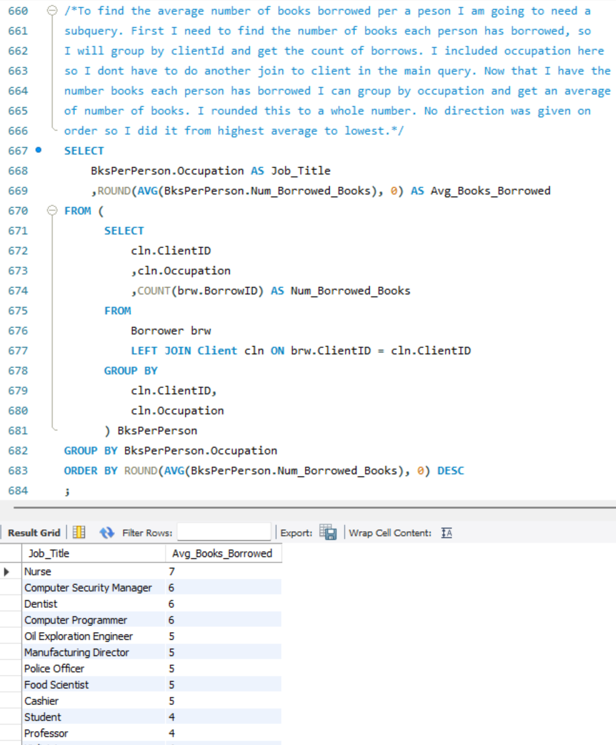

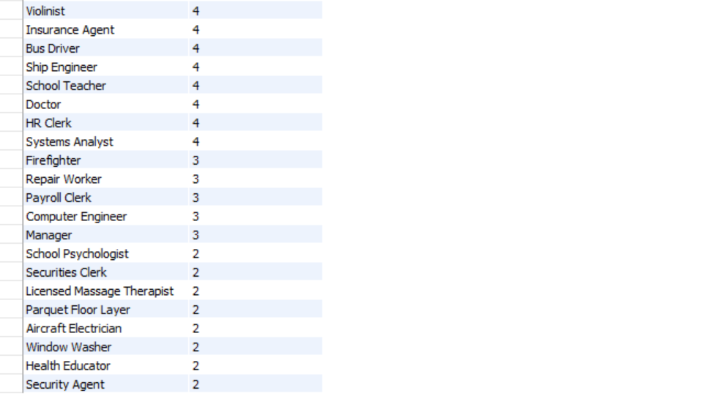

1. **Create a VIEW and display the titles that were borrowed by at least 20% of clients**

/*First, I need to get the total number of clients that borrowed each book. To do that I will group by bookID and count the distinct number of clients that have borrowed it. Now I need to make sure the total number of clients that have borrowed each book is greater than or equal to 20% of all clients. To do that I need to find out what 20% of clients is. I will count the amount of ClientID’s in the client table, and then times that by .20 to get to 20%. Then I will round to a whole number. Now to compare that number to the number of clients that have borrowed each book I need to use a HAVING statement instead of a WHERE statement because I am using a GROUP BY and the thing I am comparing against is a product of the group by. */

CREATE VIEW PopularBooks AS

SELECT

bk.BookTitle

FROM

Borrower brw

LEFT JOIN Book bk ON brw.BookID = bk.BookID

GROUP BY brw.BookID

HAVING COUNT(DISTINCT brw.ClientID) >=

(SELECT

ROUND((COUNT(cln.ClientID) *.2),0) AS TwentyPercentOfClients

FROM

Client cln )

;

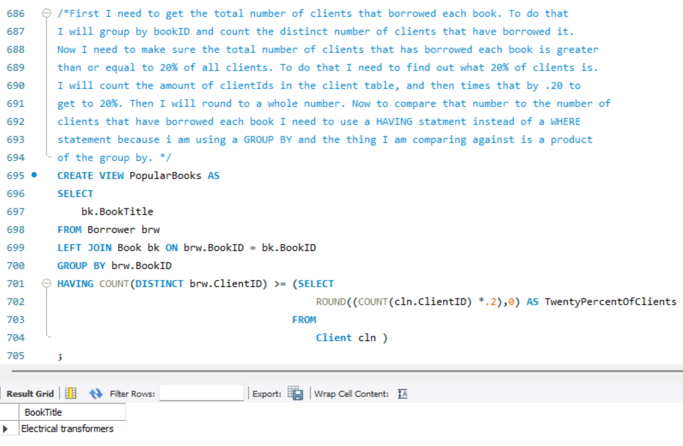

1. **The top month of borrows in 2017**

/*To find the month in 2017 with the most books borrowed I needed to group by the month borrowed and get a count of borrowIDs - and limit to 2017. After doing this I saw that three months had the same top amount of borrows. To make sure I select all there I made my query into a CTE and then selected the max number of books from that table to limit the months that display. */

WITH MaxBorrow AS

(SELECT

MONTH(brw.BorrowDate) AS BorrowMonth

,COUNT(brw.BorrowID) AS TotalBooks

FROM

Borrower brw

WHERE

YEAR(brw.BorrowDate) = 2017

GROUP BY MONTH(brw.BorrowDate)

)

SELECT mxbr.BorrowMonth

FROM MaxBorrow mxbr

WHERE mxbr.TotalBooks = (SELECT MAX(TotalBooks) FROM MaxBorrow)

;

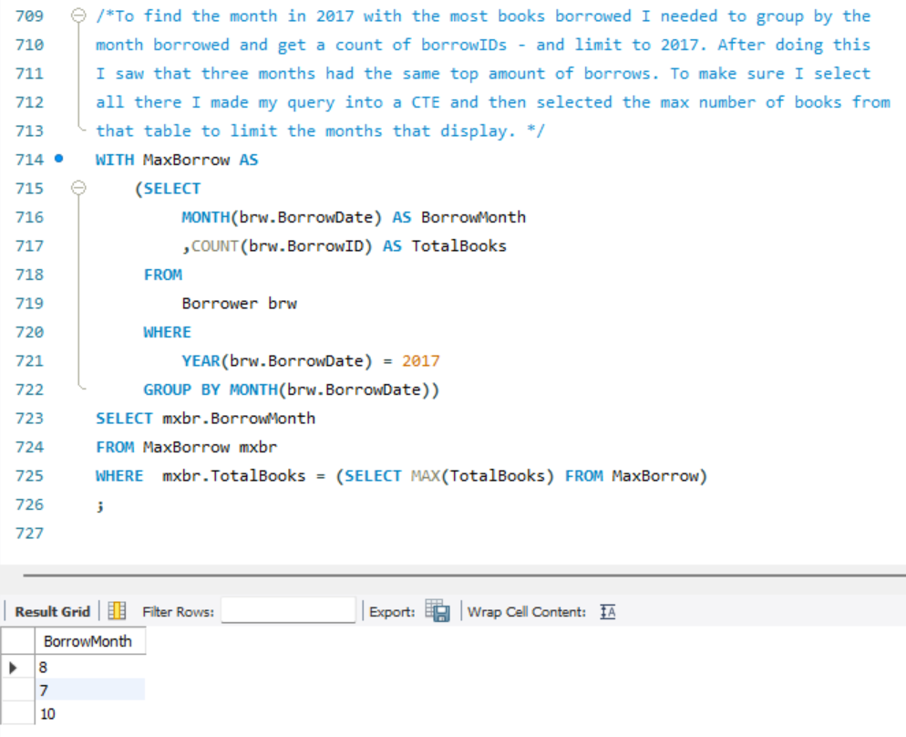

1. **Average number of borrows by age**

/*To get average books per age I will make a query similar to average books per occupation but switch out occupation for age plus do the age calculation. */

SELECT

BksPerPerson.ClientAge

,ROUND(AVG(BksPerPerson.Num_Borrowed_Books), 0) AS Avg_Books_Borrowed

FROM (

SELECT

cln.ClientID

,(2025 - cln.ClientDOB) AS ClientAge

,COUNT(brw.BorrowID) AS Num_Borrowed_Books

FROM

Borrower brw

LEFT JOIN Client cln ON brw.ClientID = cln.ClientID

GROUP BY

cln.ClientID

,(2025 - cln.ClientDOB)

) BksPerPerson

GROUP BY BksPerPerson.ClientAge

ORDER BY ROUND(AVG(BksPerPerson.Num_Borrowed_Books), 0) DESC

;

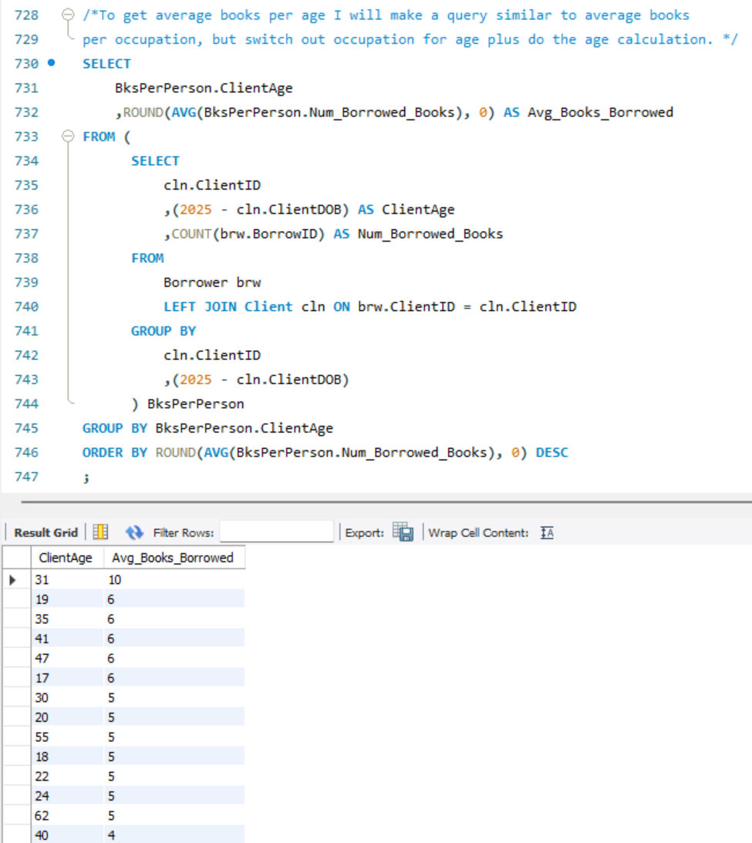



1. **The oldest and the youngest clients of the library**

/*To find the youngest and older clients we need to find the min and max dates of birth in the Clients table. Because we only have the year they were born, there could be multiple people that tie for oldest or youngest person. What columns to display were not specified so I listed all their information*/

SELECT

*

FROM

Client cln

WHERE

cln.ClientDOB = (SELECT MIN(ClientDOB) FROM Client)

OR cln.ClientDOB = (SELECT MAX(ClientDOB) FROM Client)

ORDER BY cln.ClientDOB DESC

;

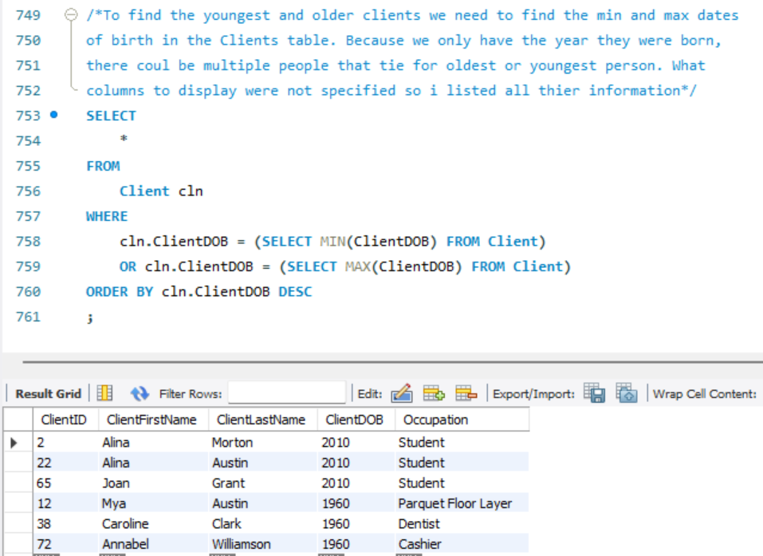

1. **First and last names of authors that wrote books in more than one genre**

/*To find authors that wrote books in multiple genres I need to count the distinct

number of genres each other has popped up in. In this case no authors have written

books in different genres? */

SELECT

ath.AuthorFirstName

,ath.AuthorLastName

FROM

Book bk

LEFT JOIN Author ath ON bk.AuthorID = ath.AuthorID

GROUP BY ath.authorId

HAVING COUNT(DISTINCT bk.genre) > 1

;

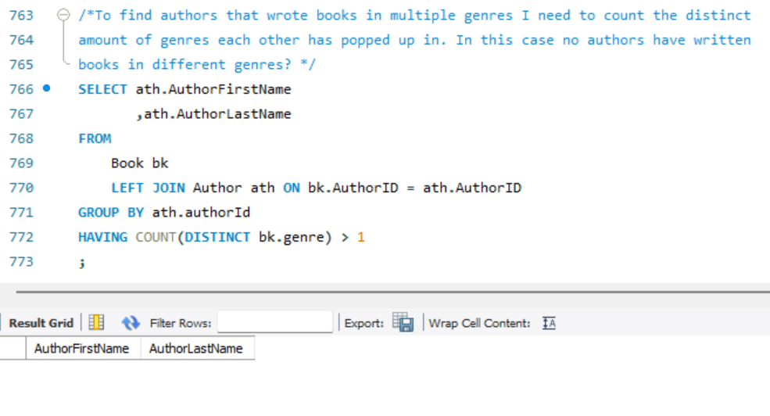

/*Create index on frequently used columns in queries*/

CREATE INDEX BkAuthIndx ON Book(AuthorID);

CREATE INDEX BrwClnIndx ON Borrower(ClientID);

CREATE INDEX BrwBkIndx ON Borrower(BookID);

CREATE INDEX ClnOccuIndx ON Client(Occupation);

